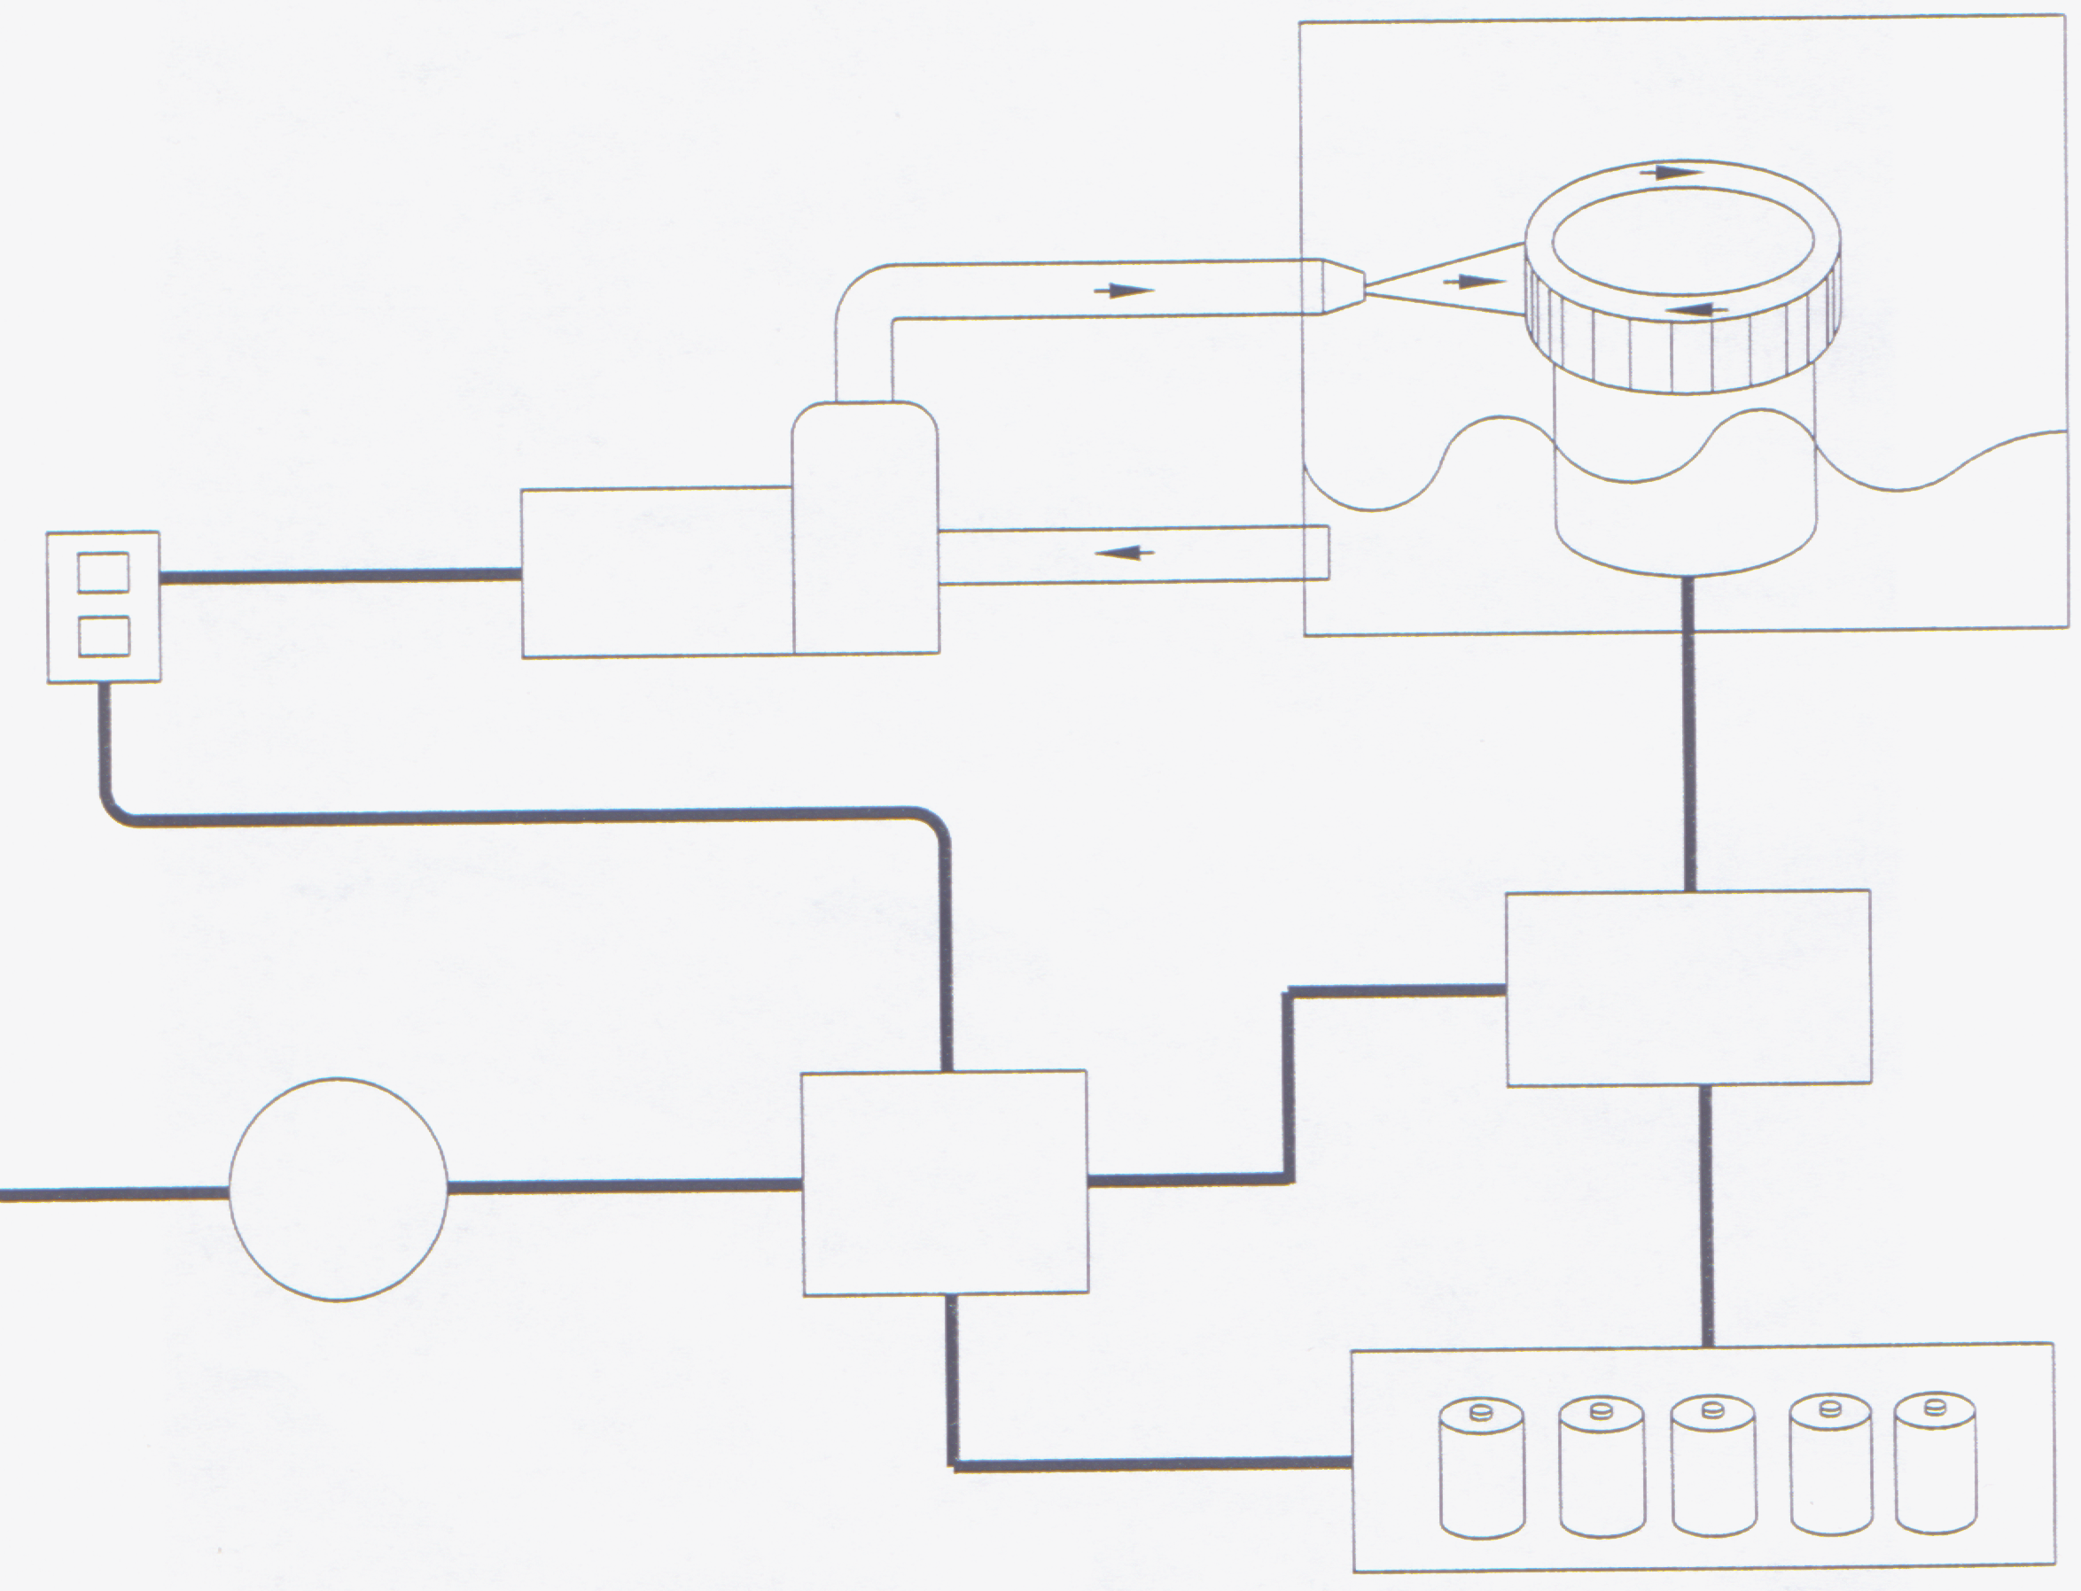
SELF-POWERED HYDRO-ELECTRIC POWER-GENERATOR PROVISIONAL APPLICATION #60/363271

Confirmation No. 4014 Utility Patent No. 10/136521
(1-A)
POWER SUPPLY
(1-B)
WATER PUMP
(1-C)
NOZZLE FROM WATER PUMP IS DIRECTED SUCH THAT WATER FLOW FROM PUMP WILL MOVE TURBINE IN THE MOST EFFICIENT MANNER
(1-D)
SEALED CONTAINER WITH WATER AT BOTTOM
(2-A)
GENERATOR CONVERTS TORQUE TO ELECTRICITY
(OPTIONAL)-(2-C)
BATTERIES AUXILIARY POWER
(1-F)
WATER-FLOW BACK TO PUMP THRU SEALED WATER LINE RECIRCULATE THE WATER
(2-E)
ELECTRIC METER (OPTIONAL)
2-F
EXCESS POWER GOES TO POWER GRID
INVENTOR’S NAME:
ROBERT WILLIAM JACKSON
RR 2 BOX 142
HINTON, OKLAHOMA 73047
(405) 284-6395
(2-B)
TRANSFORMER
STEP UP OR STEP DOWN IT DEPENDS ON HOW POWER IS TO BE USED
(1-E)
ROTATING TURBINE GENERATES TORQUE
2-D
SWITCHGEARS (SWITCHES AND/OR CIRCUIT BREAKERS REGULATE AND DIRECT POWER INTO POWER LINES). TYPE AND NUMBER SWITCHES DEPENDS ON POWER OUTPUT COMING FROM TRANSFORMER
Sheet 1 ( 2

